**1)**  **Admin is unable to access Proxy management**

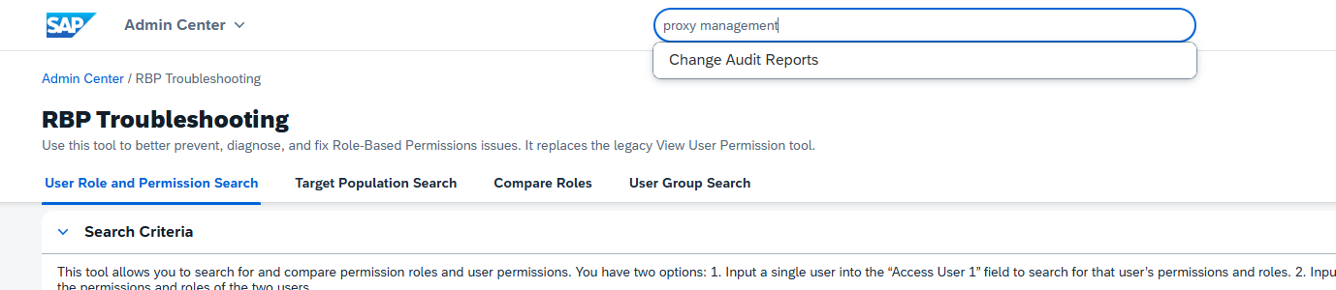

1. As the admin is part of the “Super Admins” group. We dont need to look it up in Permission Groups.
2. Go to “Manage Role Permissions” from the top search bar and select “System Admin (Full Permissions)”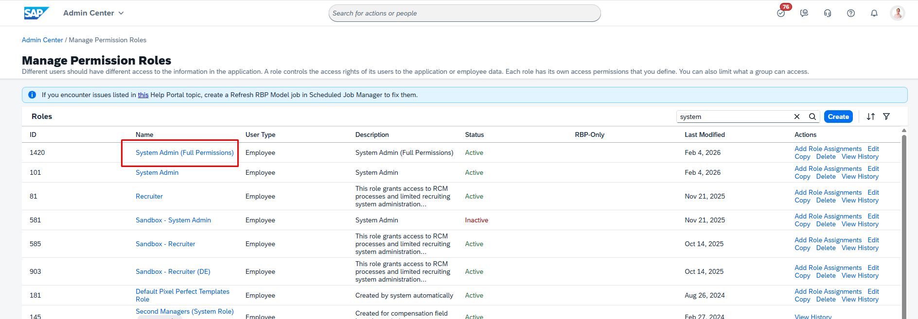
3. Click the edit button at the top right.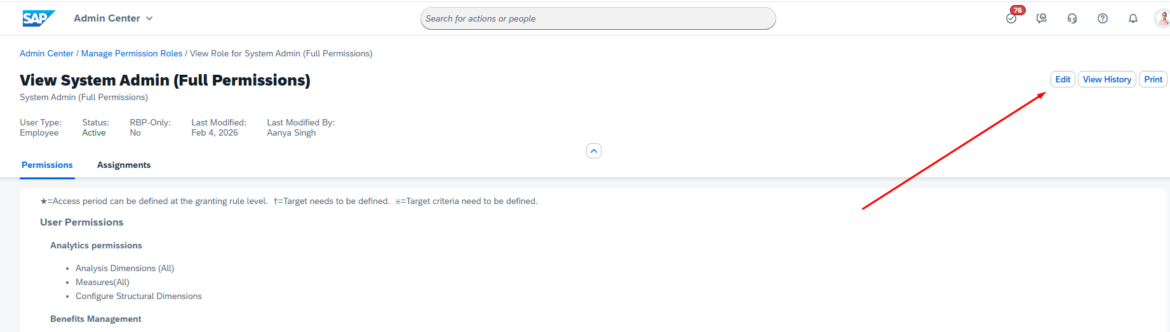
4. Click Next on the Basic information tab. On the Add Permissions tab, search for “Proxy Management”. This is unchecked which is causing the issue.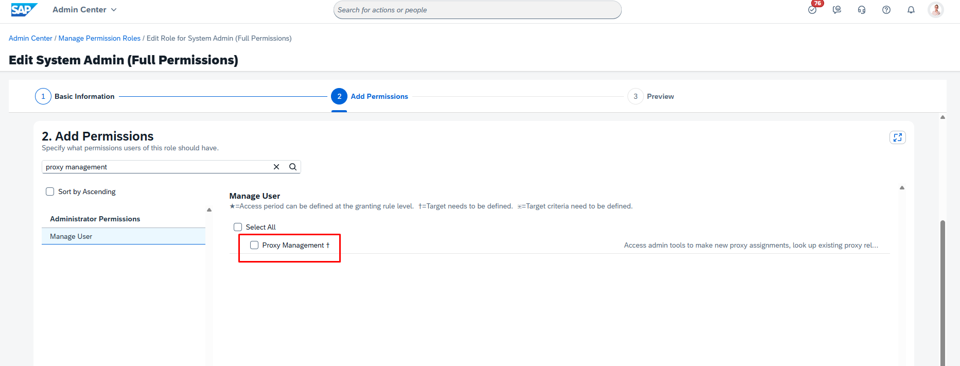
5. To verify, logout and log back in. Now you can see “Proxy Management” in the top search.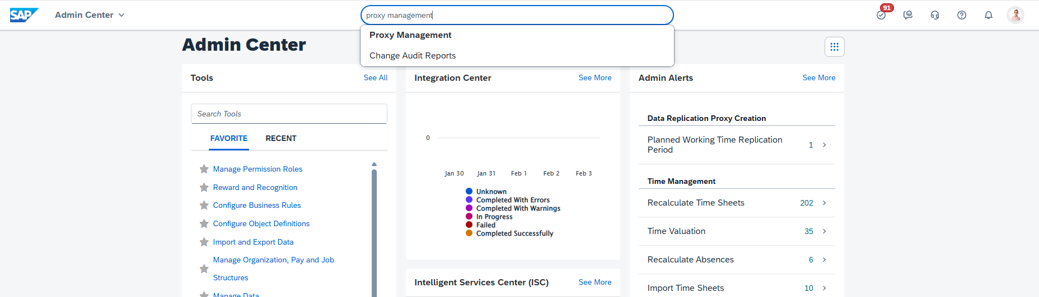

**ENDOFTASK**

**2) User Jacob Smith Cannot Access Learning Administration**

1. Type “RBP Troubleshooting” and select the action.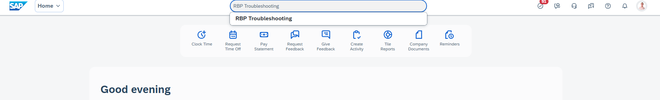
2. Select the User Group Search tab. Then type the affected user’s name (in this case Jacob Smith). Then click the search button. Now we know the group that he is a part of. “New Employees”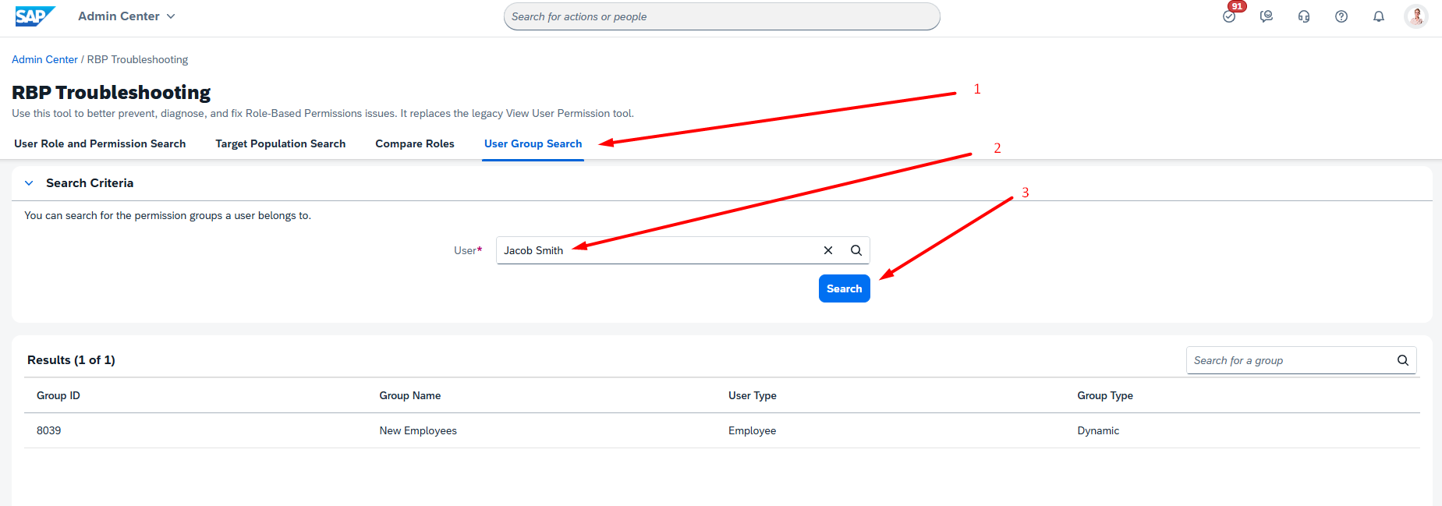
3. Go to “Manage Permission Group” and look for a group named “New Employees”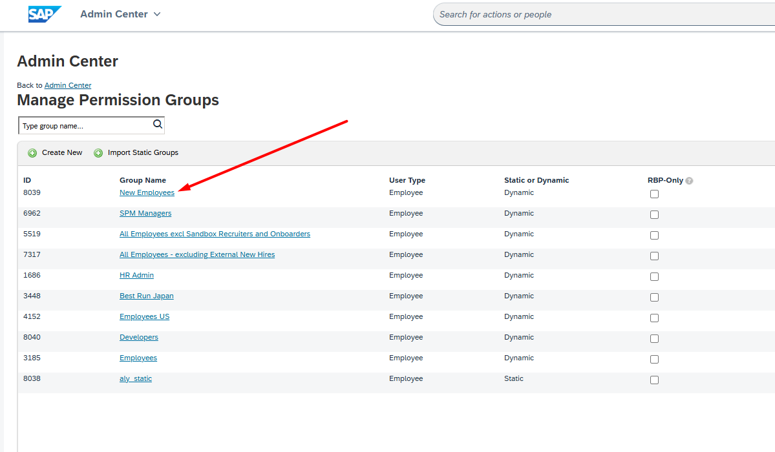
4. Click on “New Employees” Group from the list.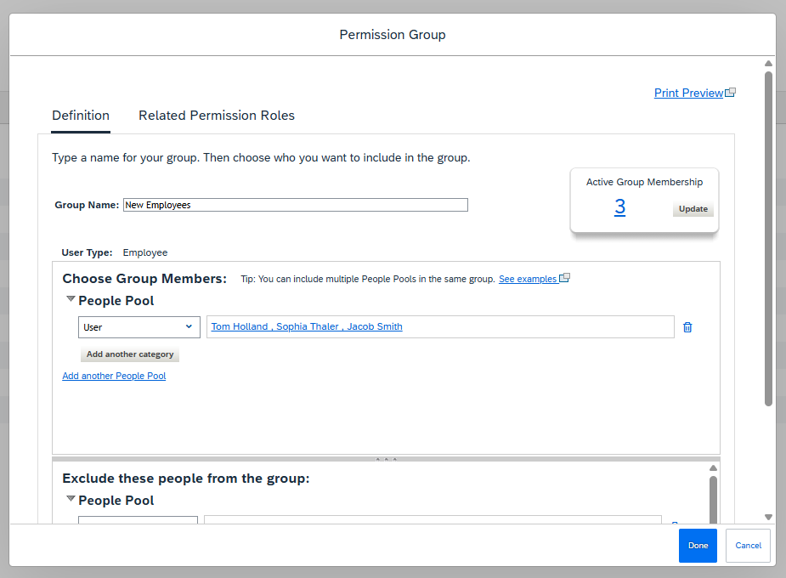
5. Check what roles are assigned to the user in the “Related Permission Roles” tab. It seems to be “Employee Self Service”.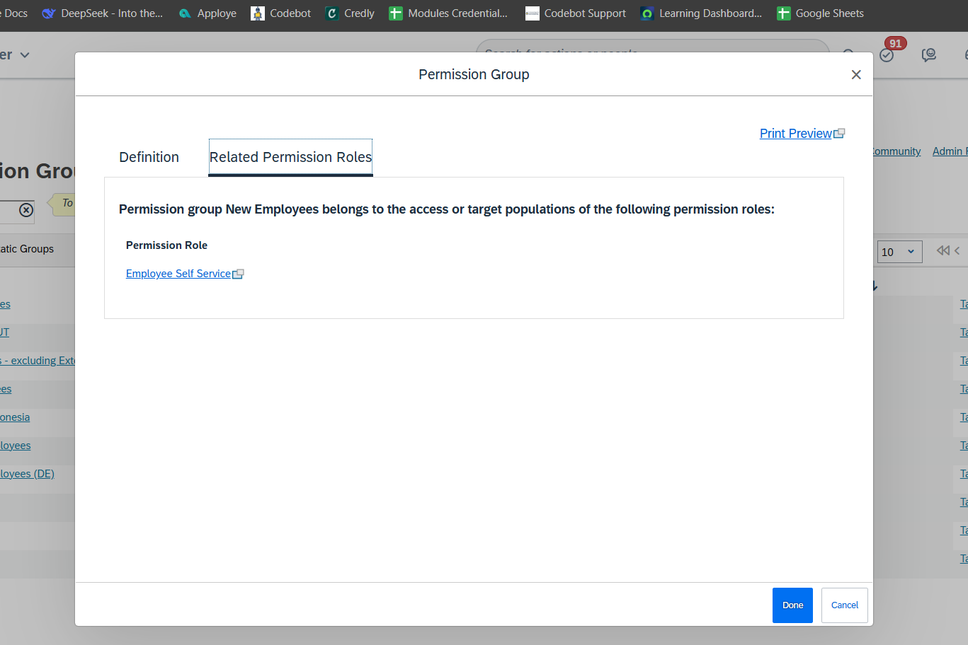
6. Now search “Manage Permission Roles” in the top search.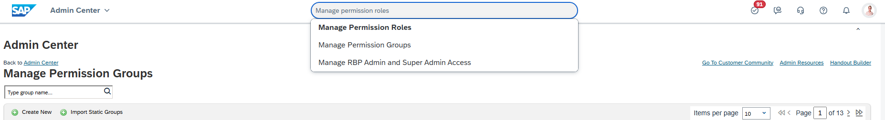
7. Now look for the “Employee Self Service” role from the list and click the edit button in front of it.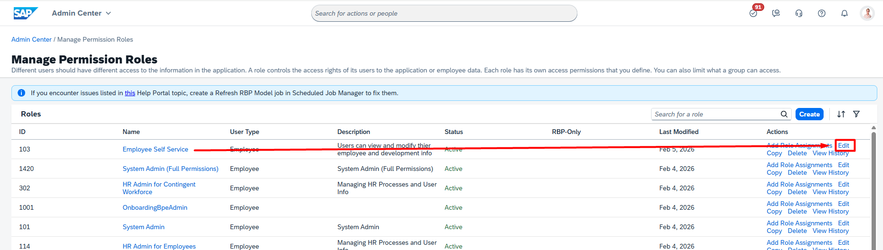
8. Click next on the Basic information tab and search for “Manage Learning” on the Add Permissions tab. Then, the “Learning admin access permission” checkbox is unchecked; therefore, this is the root cause.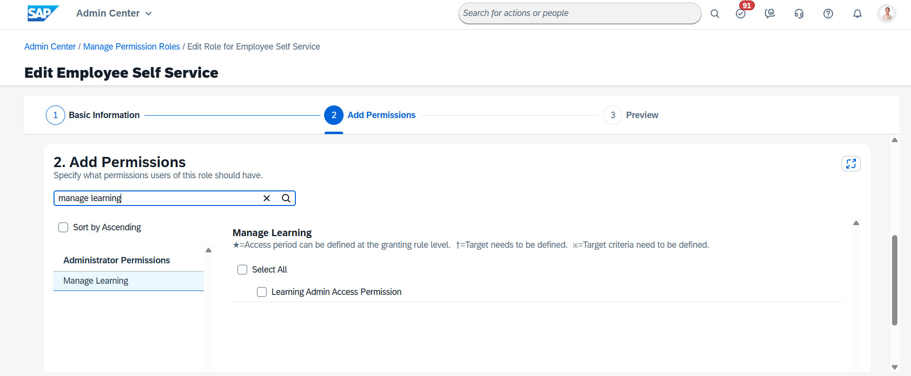
9. To Verify, click on the profile icon on the top right corner and select Proxy Now from the drop down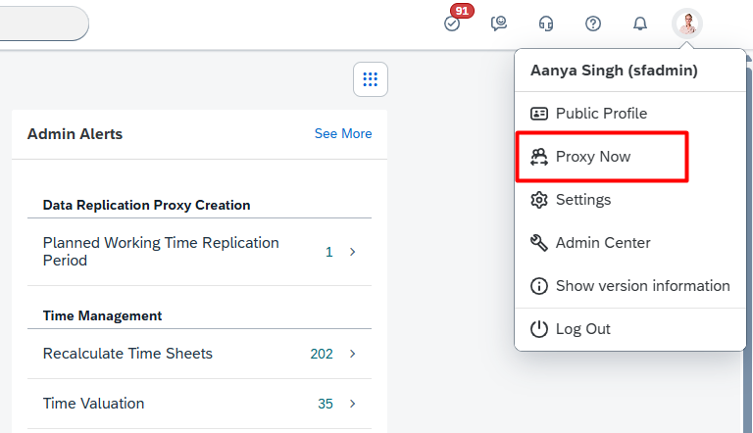
10. Type the affected user’s name in the popup, which is Jacob Smith. Select the user from the dropdown and hit Ok.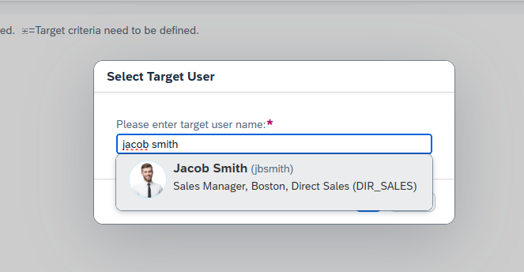
11. Now type “Learning Administration” in the top search and you can see it appear.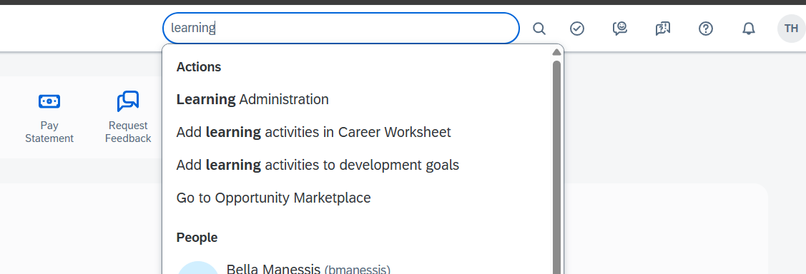

**ENDOFTASK**

**3) A User Cannot See Another User or Population.**

Sophie Thaler can see April Kennedy in the top searchbar, but other people do not show up.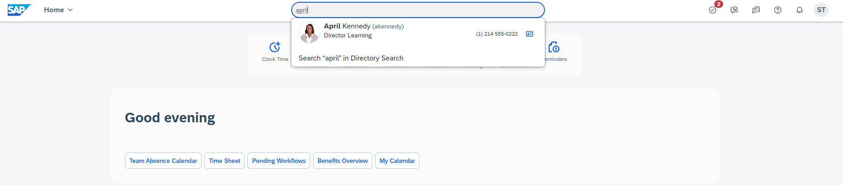

1. Go to RBP troubleshooting like the **Second task (1 to 5)** and check what group Sophie Thaler is a part of. Then open that Group in “Manage Permission Groups” to check what Roles are assigned to that group.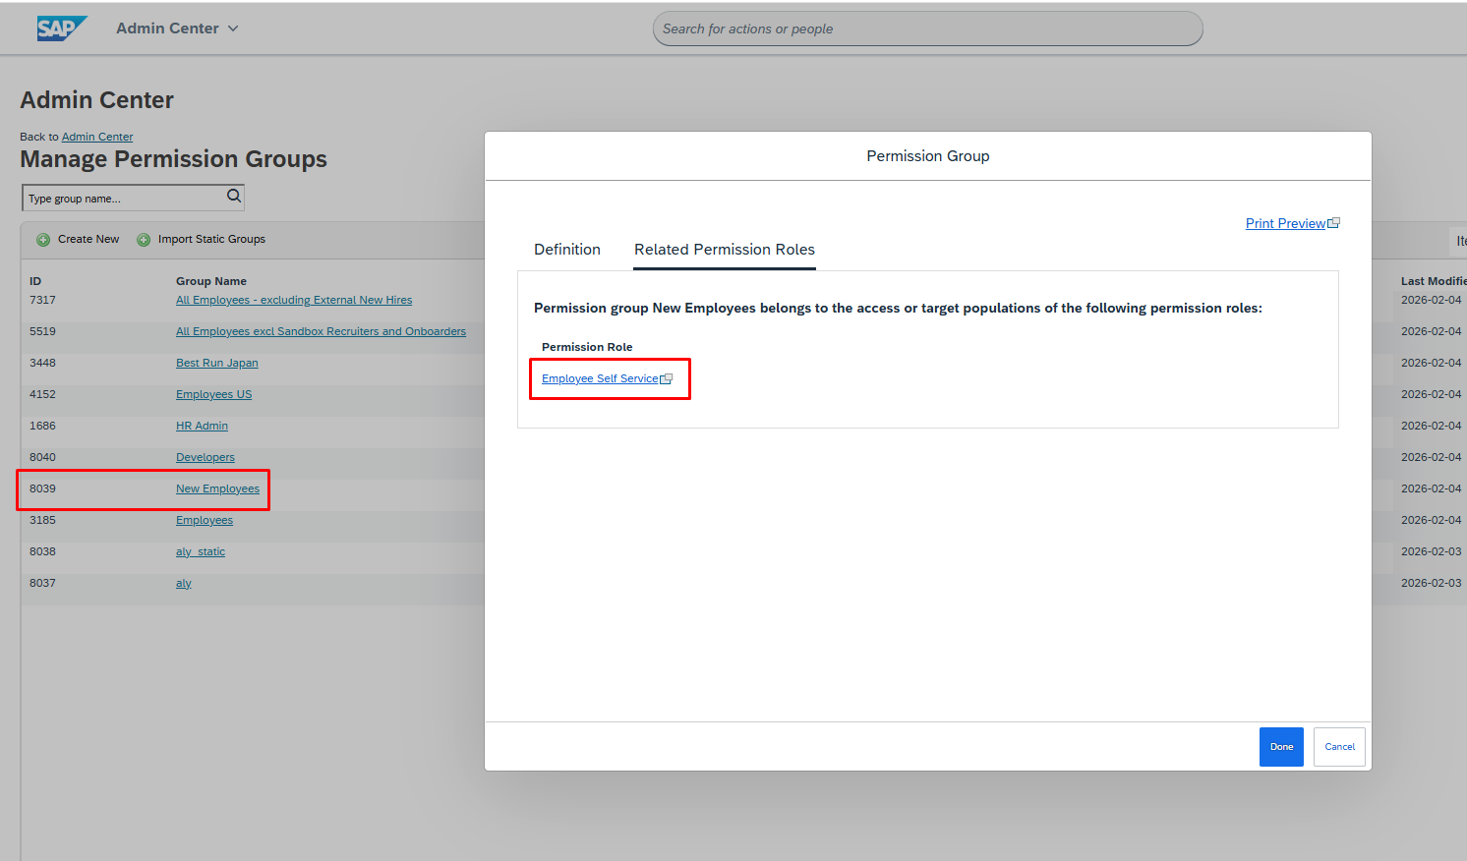
2. It is the Employee Self Service Role. Now go to “Manage Permission Roles” from top search.
3. Now click the Self Service Role from the list. 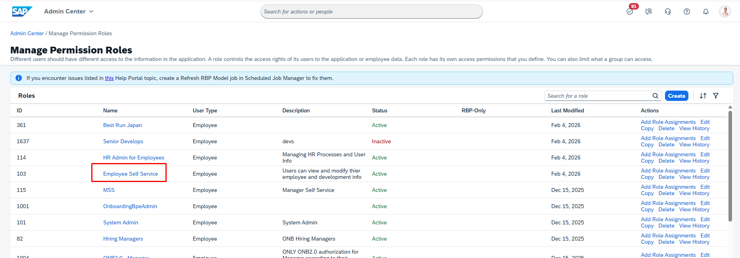
4. Click the assignments tab and then click the Edit button in front of the “New Employees” Access population Group.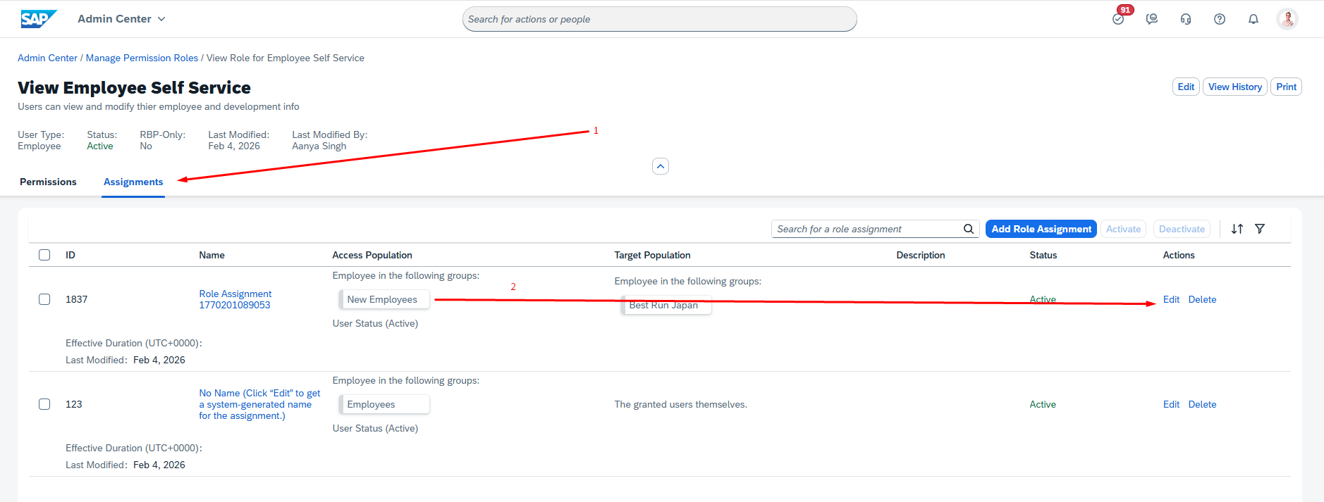
5. Click Next on the Basic Information tab and then again on the Grant access to tab. Now the “Define a Target Population Tab” is set to a filter instead of “Everyone” radiobutton which is the problem.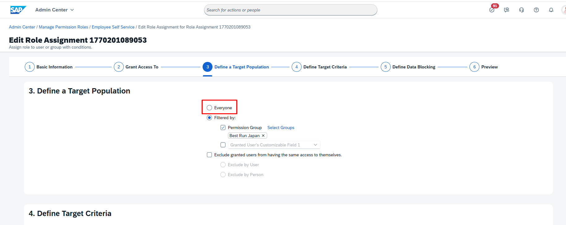
6. If it is set to “Everyone”, Sophie can now see all the employees. To Verify, click on the profile icon on the top right corner and select Proxy Now from the drop down
7. Type the affected user’s name in the popup, which in this case is Sophie Thaler. Select the user from the dropdown and hit Ok.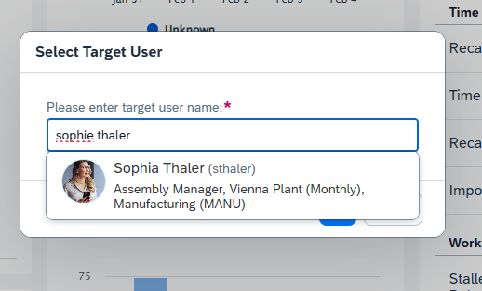
8. Now when you type other people’s names, aside from April, in the top search they will show up.

**ENDOFTASK**

**4) Joanne Pawlucky cannot see another user John Zackery’s nationality.**

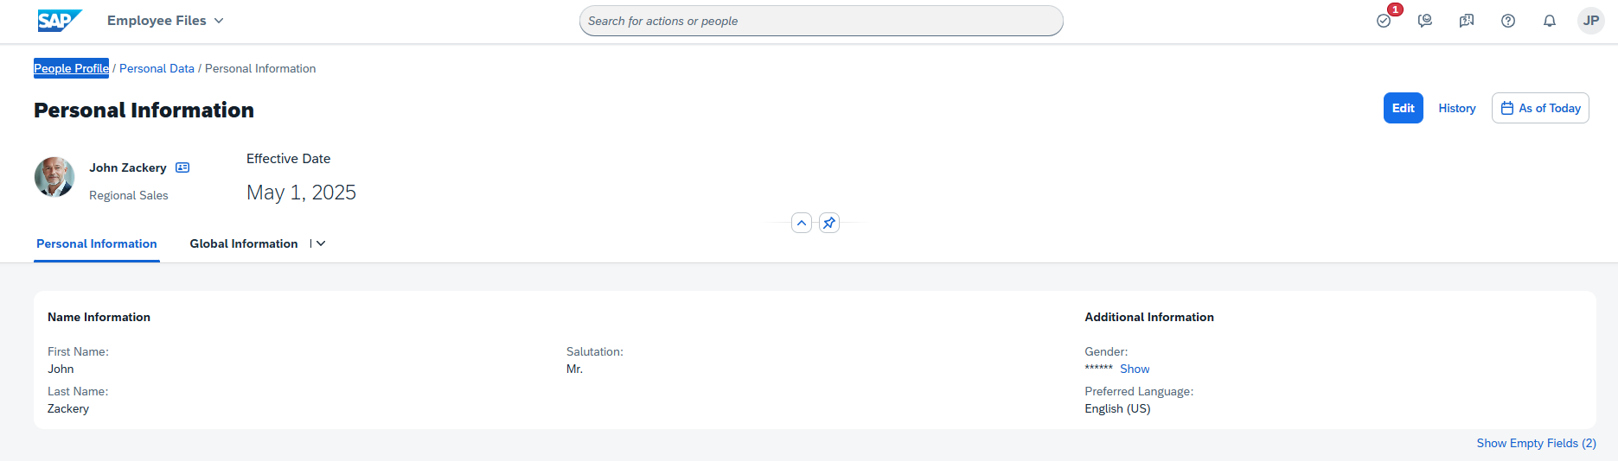

1. Go to RBP troubleshooting like the **Second task (Step 1 to 5)** and check what group Joanne Pawlucky is a part of. Then open that Group in “Manage Permission Groups” to check what Roles are assigned to that group. “HR Admin” Group.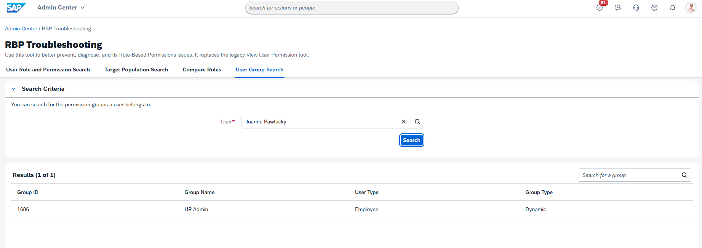
2. We will use the first role. “HR Admin for Employees”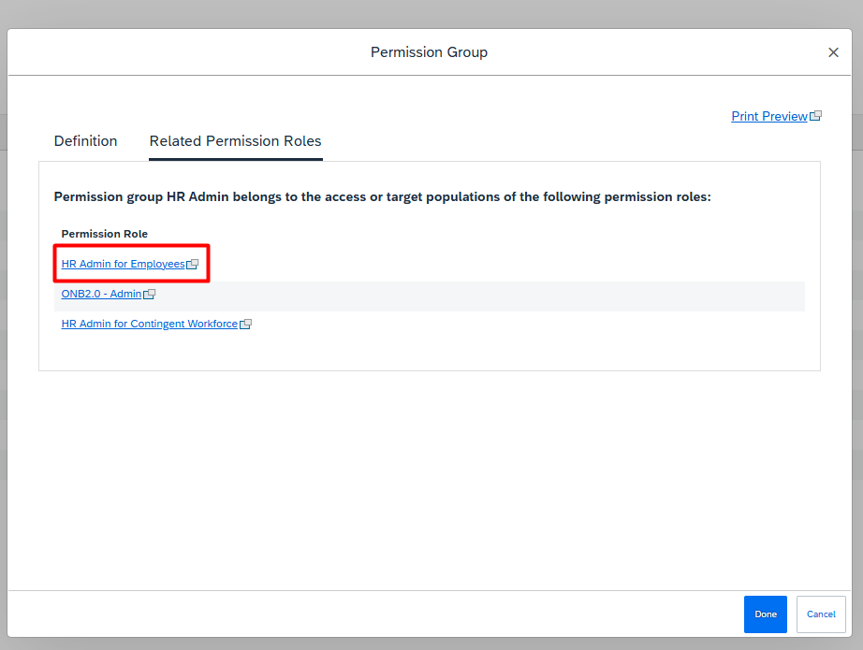
3. Go to “Manage Permission Roles” and select “HR Admin for Employees” from the role list.
4. On the Add Permissions tab search for “Employee Central Effective Dated Entities” and search for Nationality in the list. This is unchecked which is causing the problem.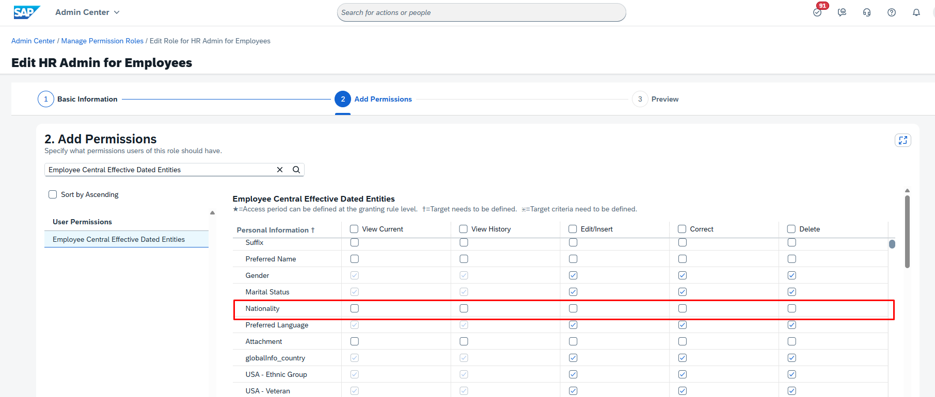
5. If it was checked, Proxy Joanne Pawlucky just like the previous tasks and search John Zackery in the top search and click him.
6. Click “View All” on the Personal Information section.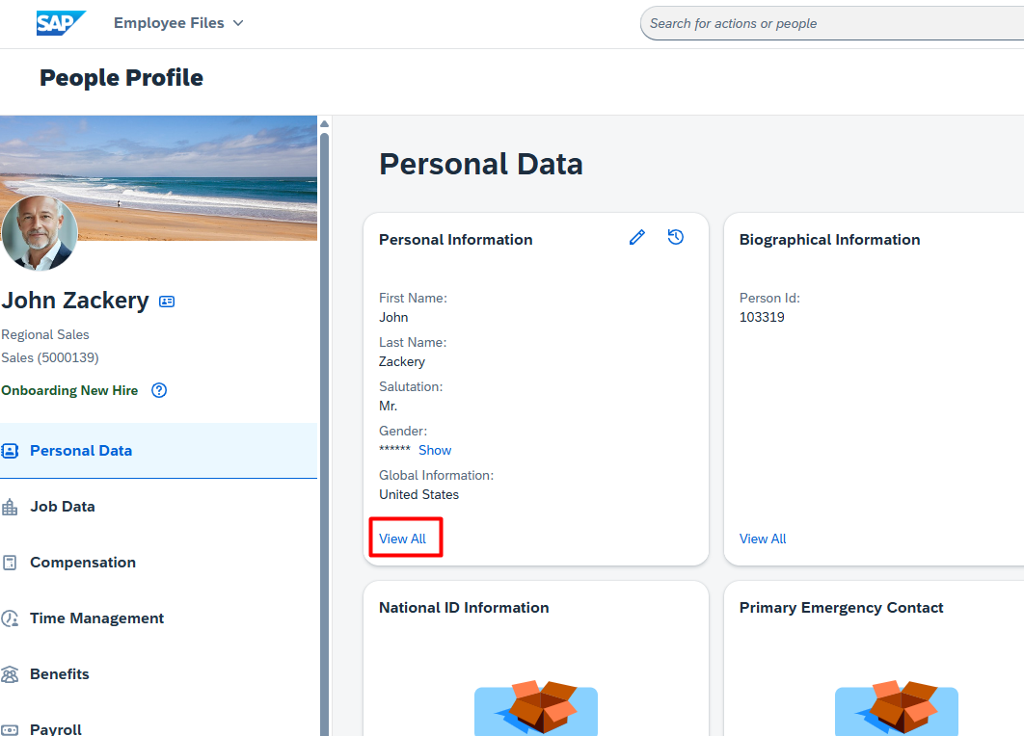
7. She is now able to see John Zackery’s nationality.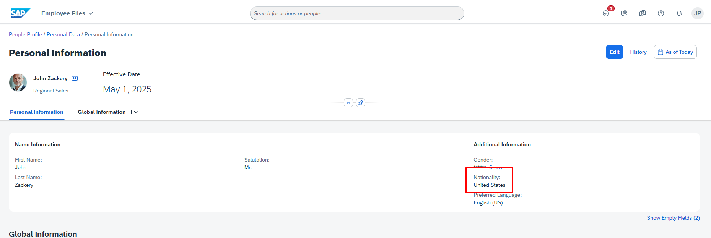

**ENDOFTASK**

**5) No Workflow Triggers on saving Home Address - City**

1. Go to “Manage Business Configuration” and select “homeAddress” from the left side. 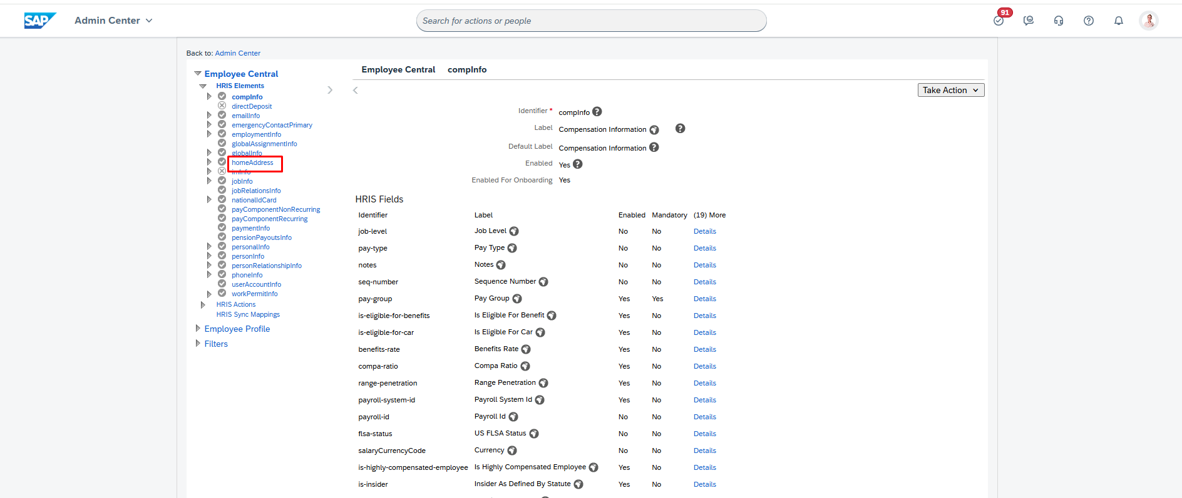
2. Click the “Take Action” button on the top right corner of the screen. Then click make correction from the dropdown.
3. Scroll to the bottom to the Trigger Rules.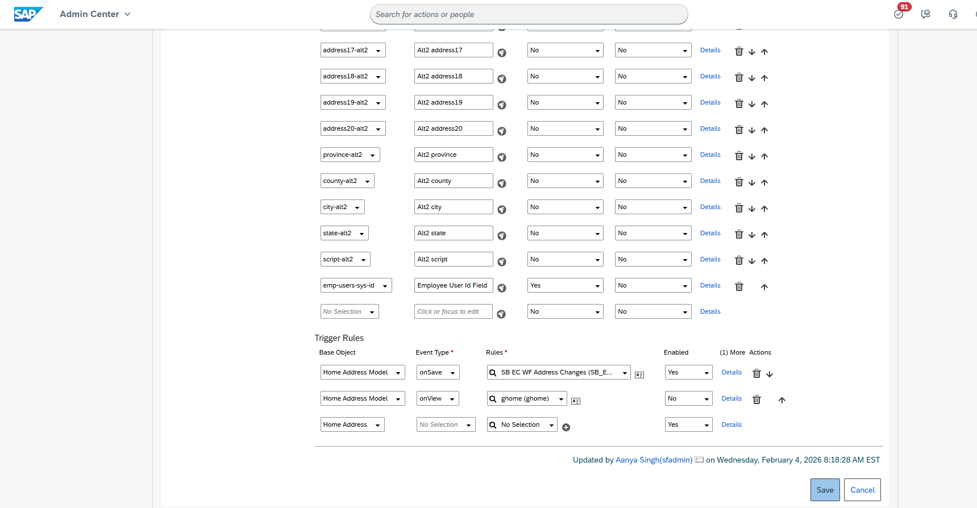
4. There needs to be a rule by setting base object as “Home Address Model”, Event Type “OnSave” and Rule as “EC WF Address Changes”, which is missing here and is the root cause of this issue.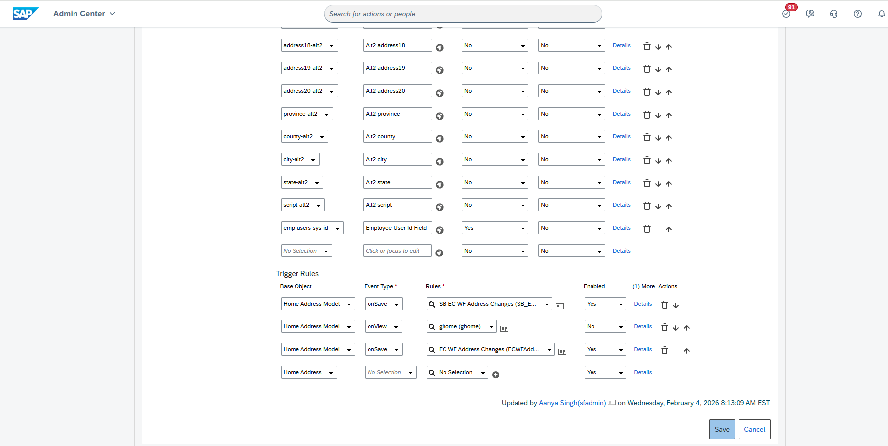
5. To verify, go to the profile of the person by searching Jack Kincaid.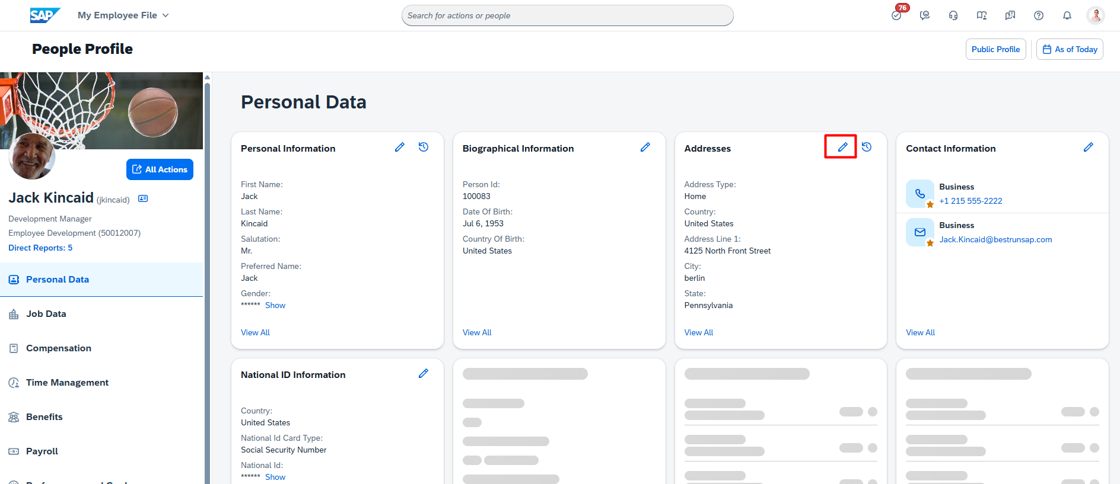
6. Now Click the pencil icon on the Addresses Section which displays this popup.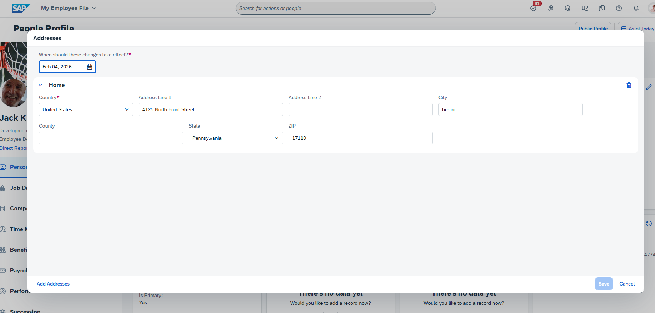
7. Now when you change the City and click Save. You are shown another popup with the approvers visible from the workflow. Click Submit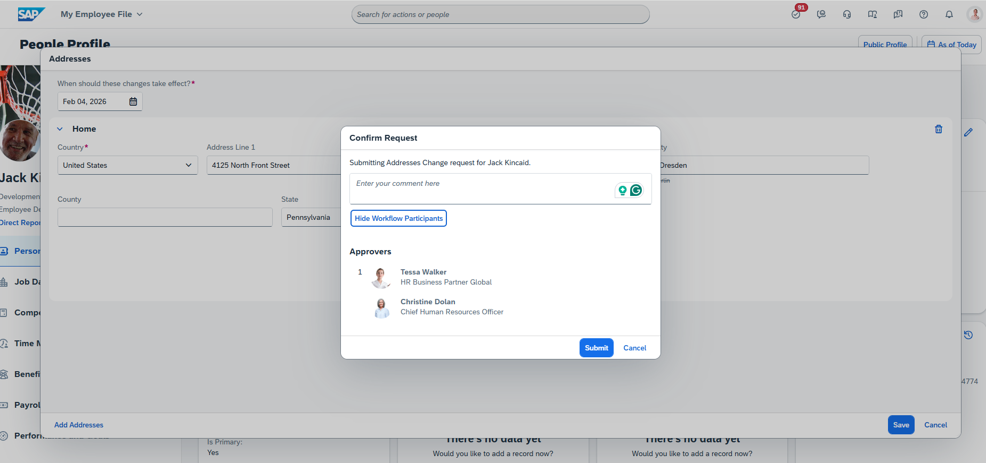

**ENDOFTASK**

**6) After changing the language on a Profile, the changes revert after saving.**

1. Search “Manage Business Configuration” in the top search bar and select “personalInfo” from the left side. 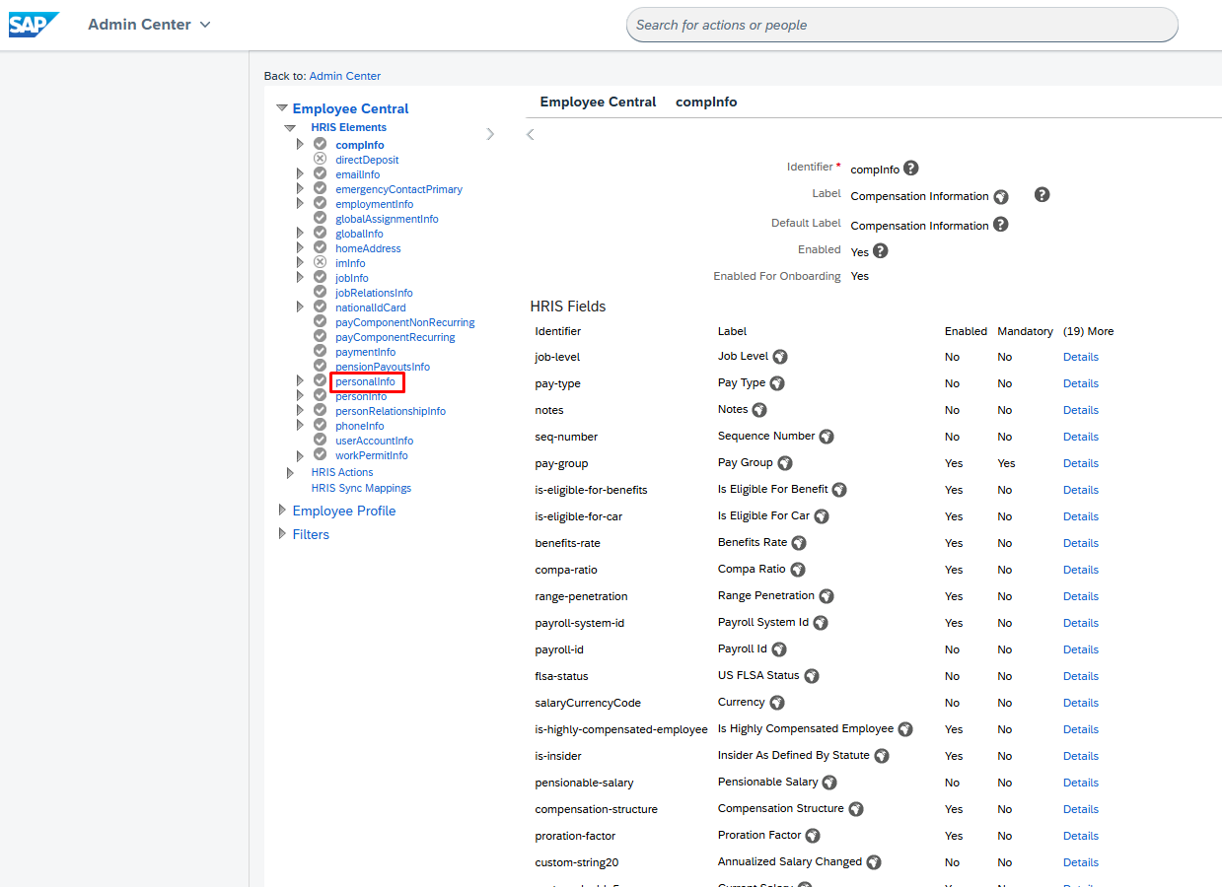
2. Click the “Take Action” button on the top right and Select Make Correction from the dropdown.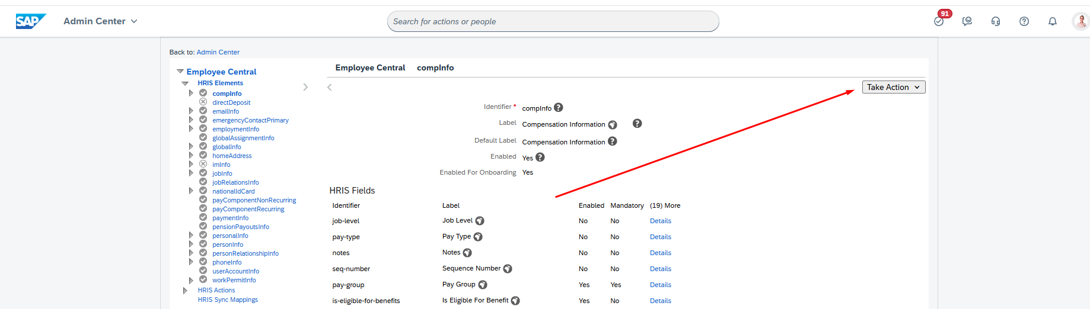
3. Scroll down to the Trigger Rules section.
4. The Enabled field to is set to Yes on EC Override Change rule. This is causing the override.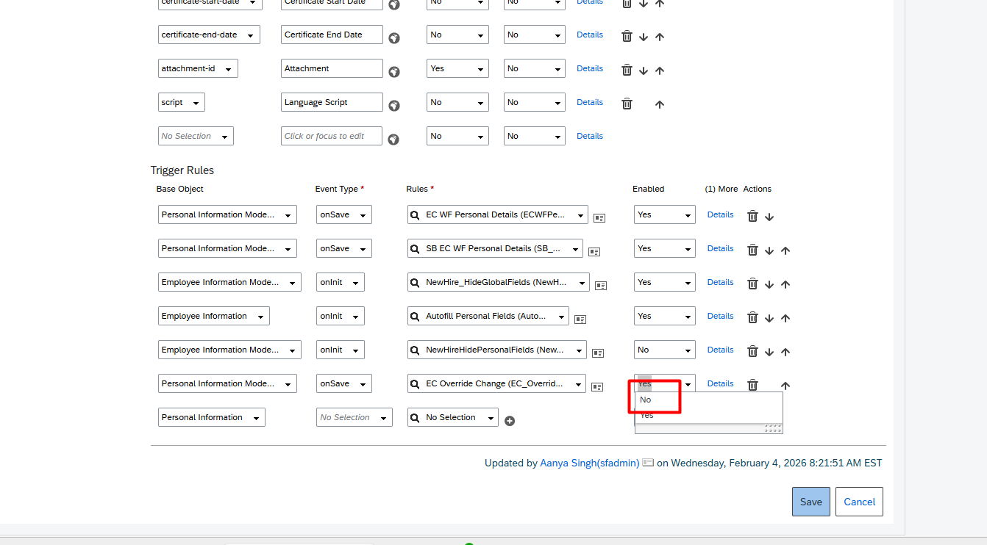
5. Now the language will not revert back when being changed on a profile which can be verified by going to Samantha Alexander’s Profile from the top search. Click the Pencil icon on the Personal Information section. Change the Preferred language and Save.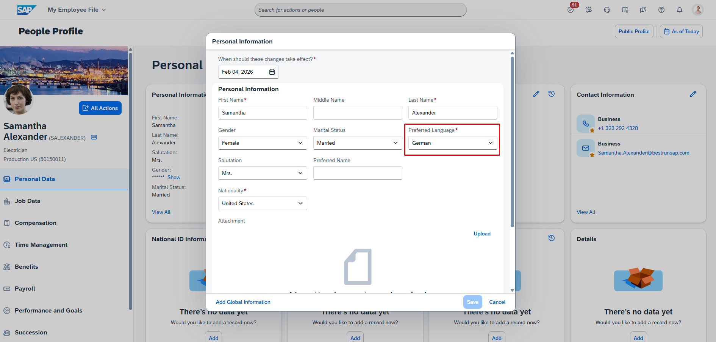

**ENDOFTASK**

**7) Workflow Should not Trigger for Preferred Name**

1. Go to “Configure Business Rules” from top search.
2. Type “personal_info” in the search bar and hit enter. Then click anywhere on the Rule.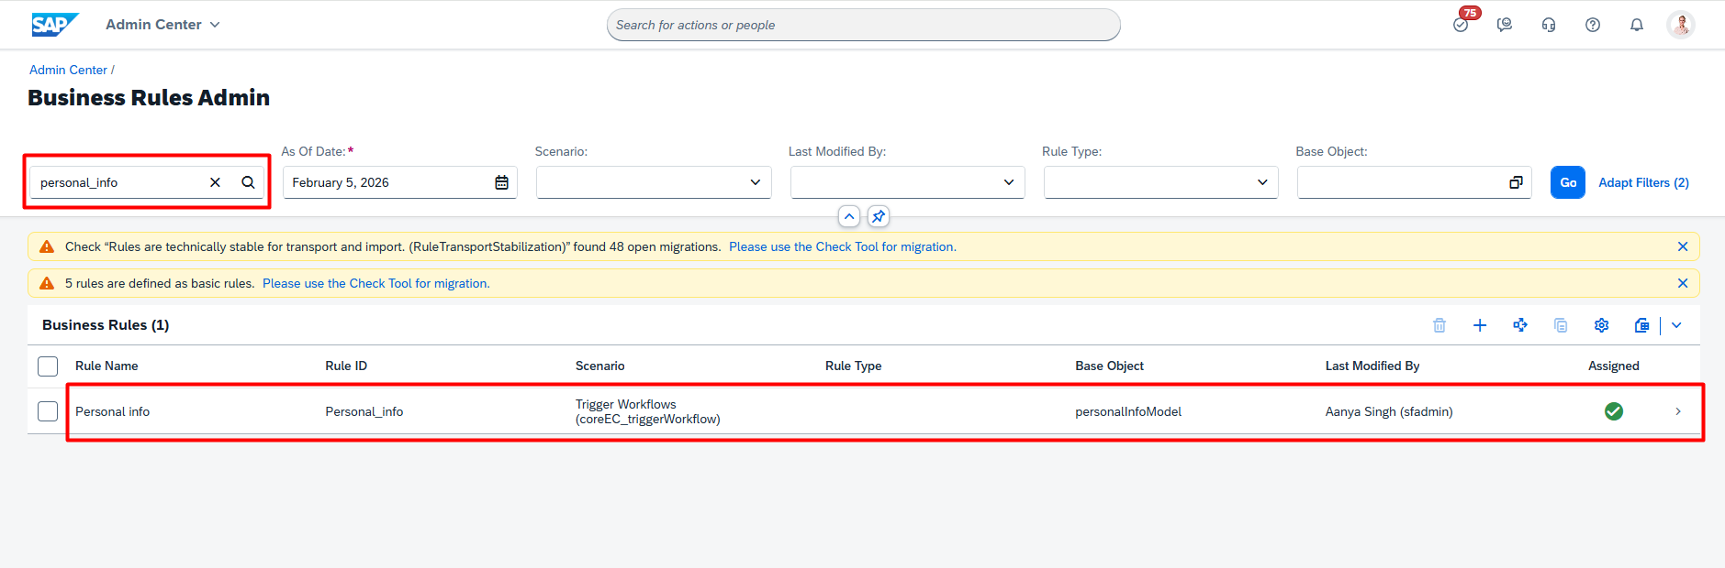
3. Click on the “Take Action” button then “Make Correction” from the dropdown.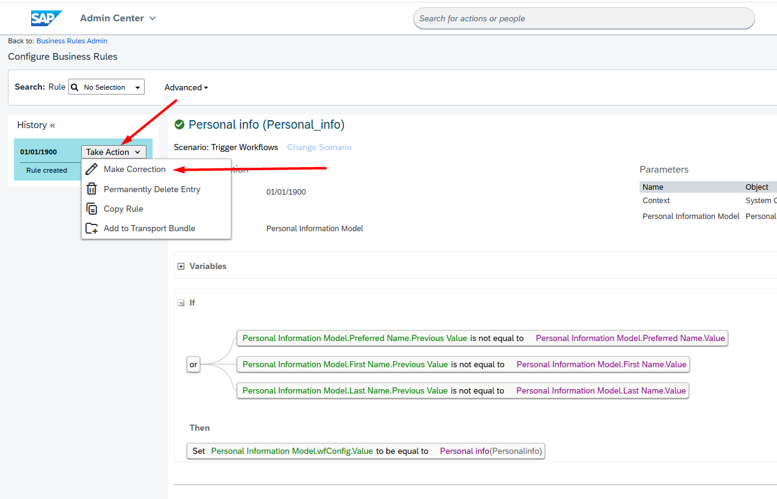
4. Here you can see the preferred Name field is part of a workflow, which is causing the issue.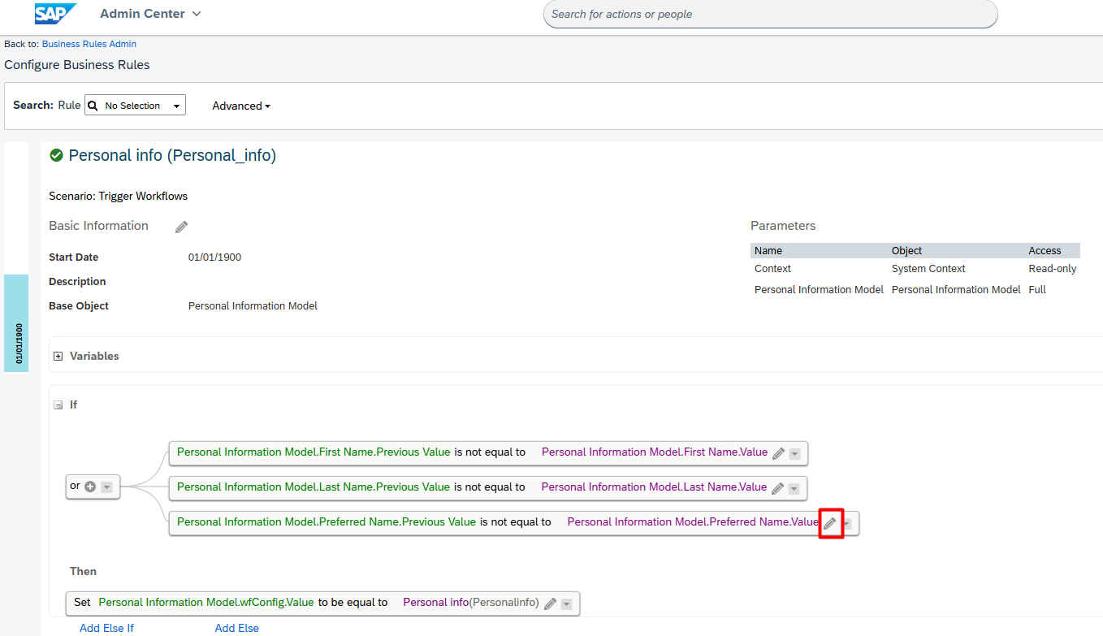
5. To verify, go to Sam Martin’s Profile from top search.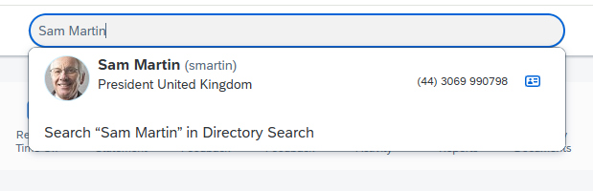
6. Click the pencil icon on the Personal Information.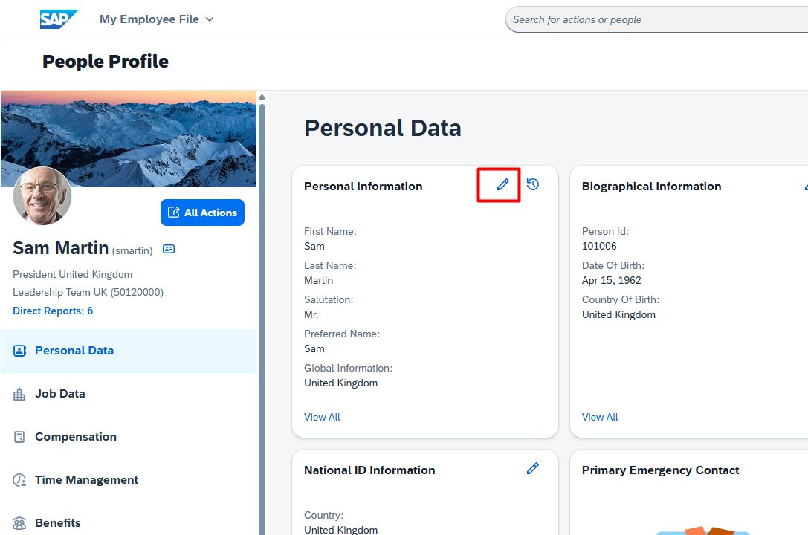
7. Change the Preferred Name and hit Save. No Workflow popup will appear.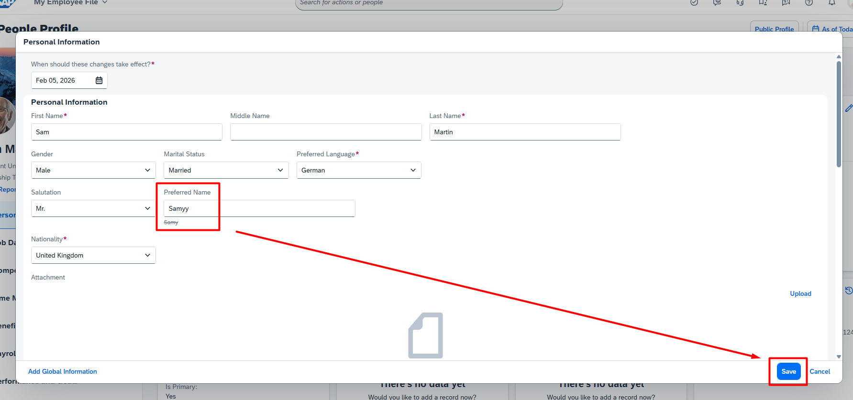

**ENDOFTASK**

**8)**  “**My Team” tile in the Organizational Updates section is missing from the Home Page**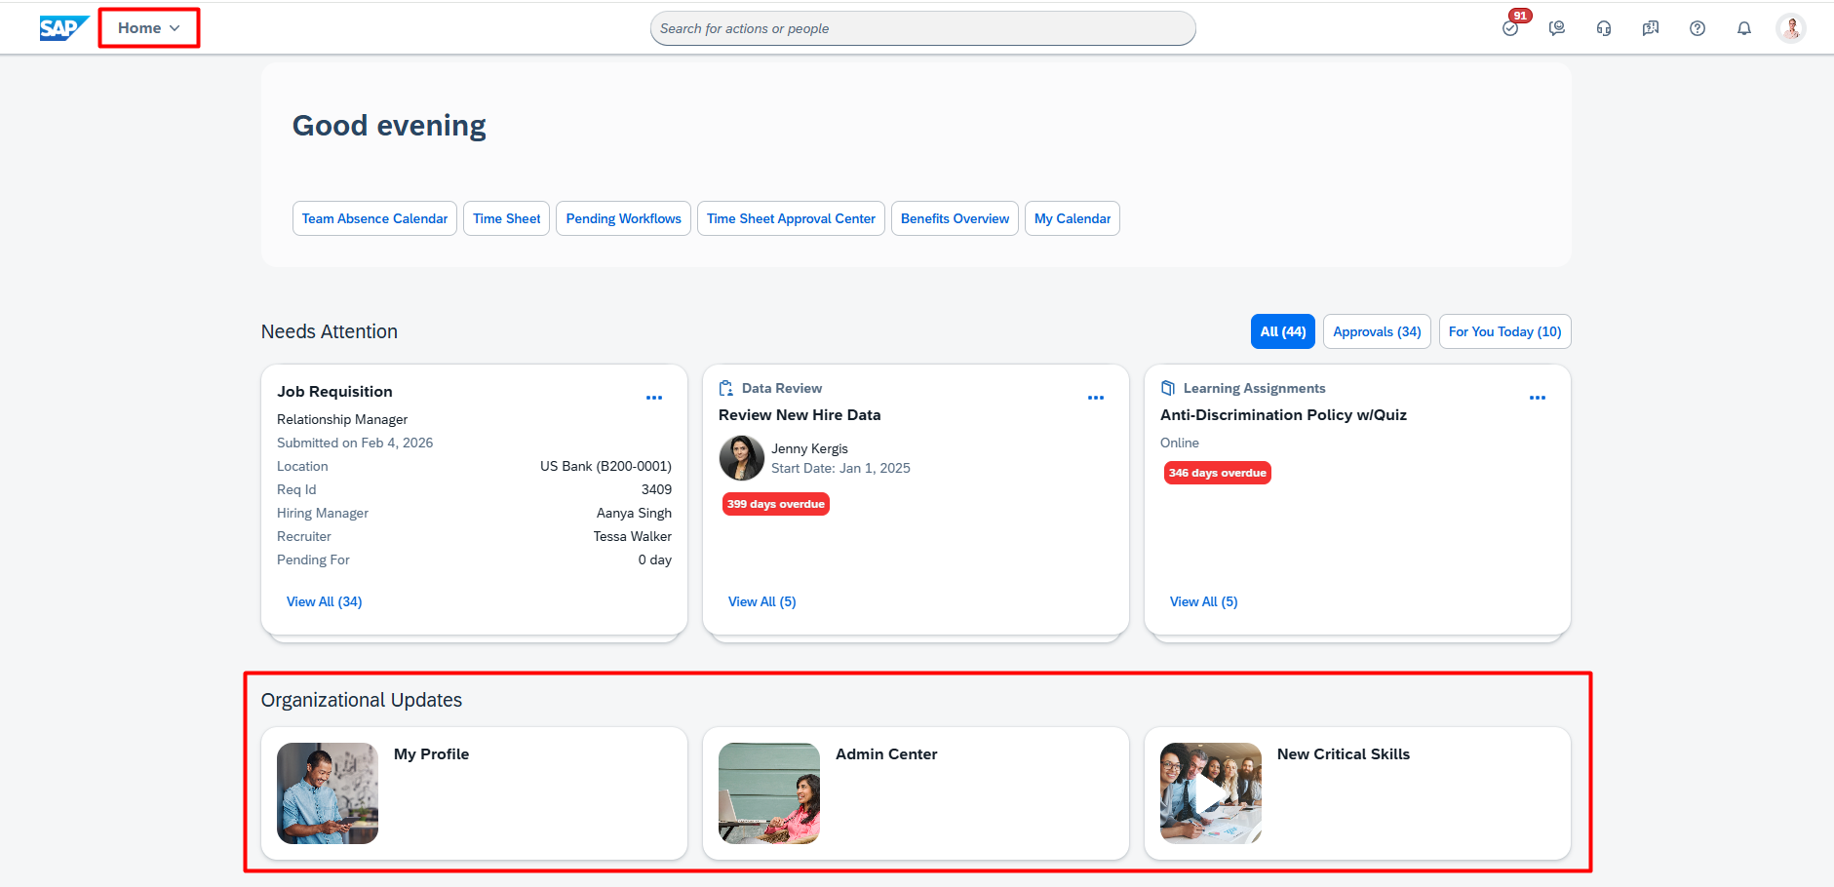

1. Search for “Manage Home Page”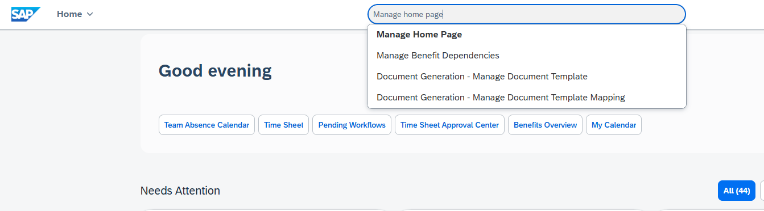
2. Click on the arrow in front of the “Organizational Updates”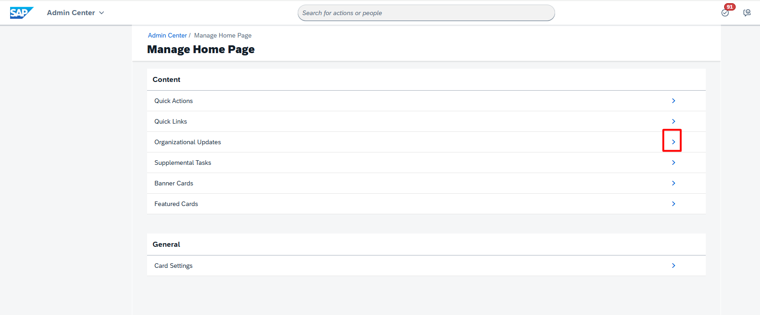
3. Expand the “Default Folder” arrow and then click on the pencil icon in row of “My Team”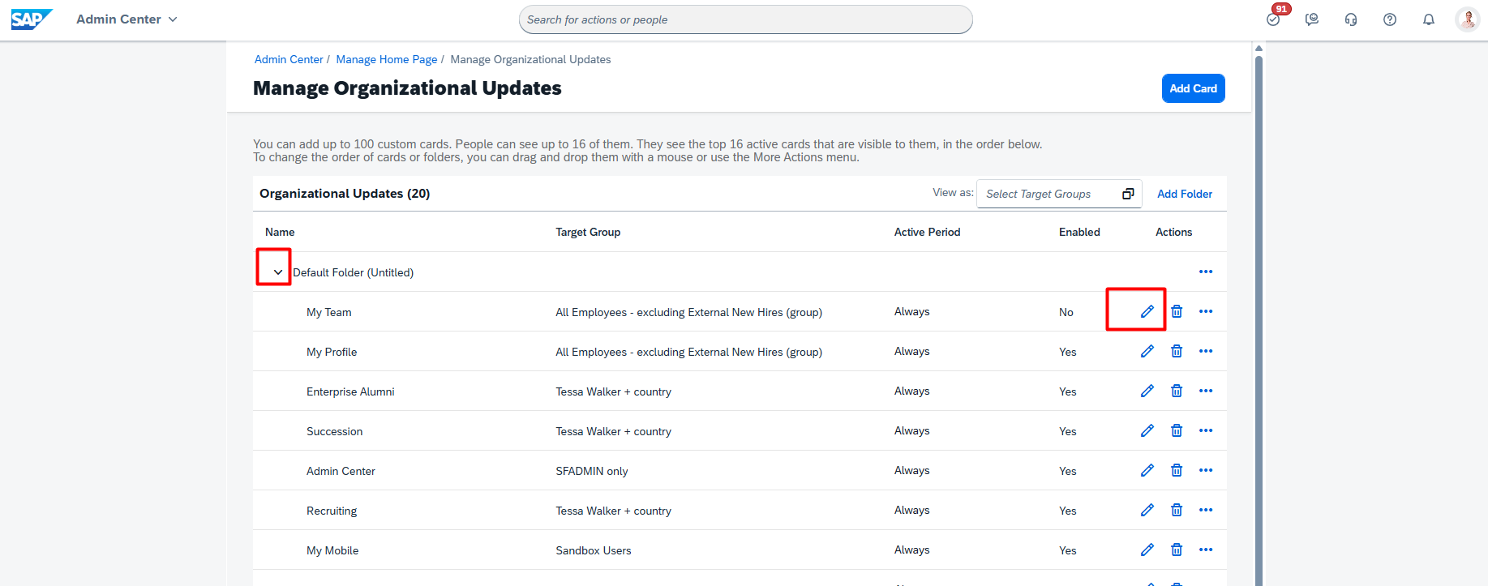
4. The Enabled button is unchecked, therefore it is not showing on the home page.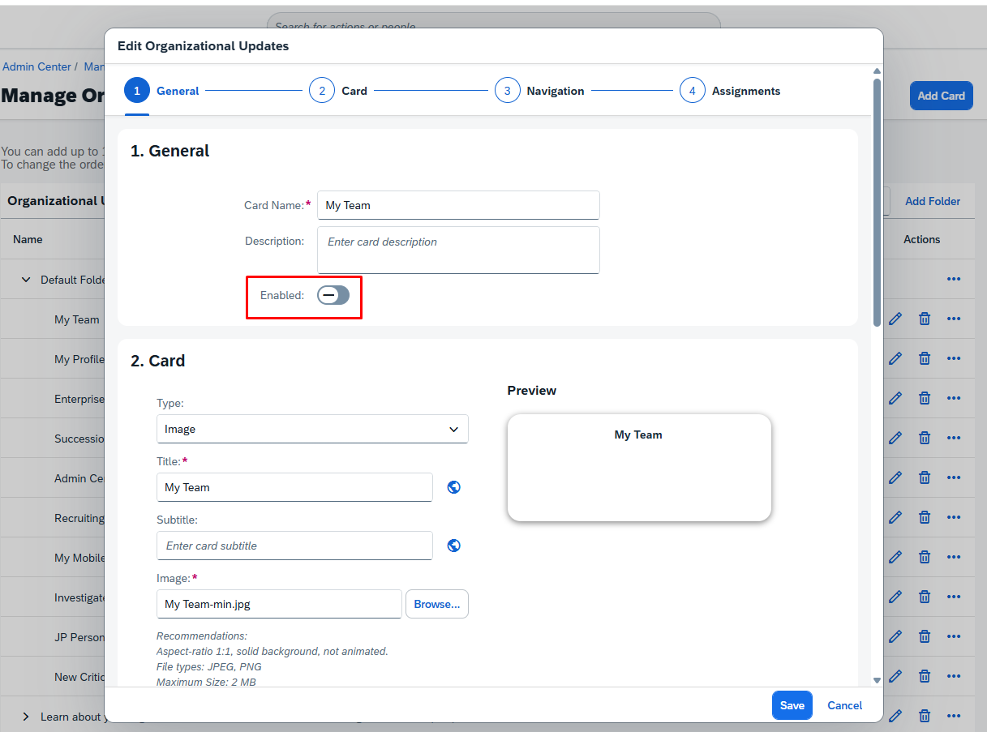
5. To verify, My Team is visible in the Organizational updates section of the Home Page.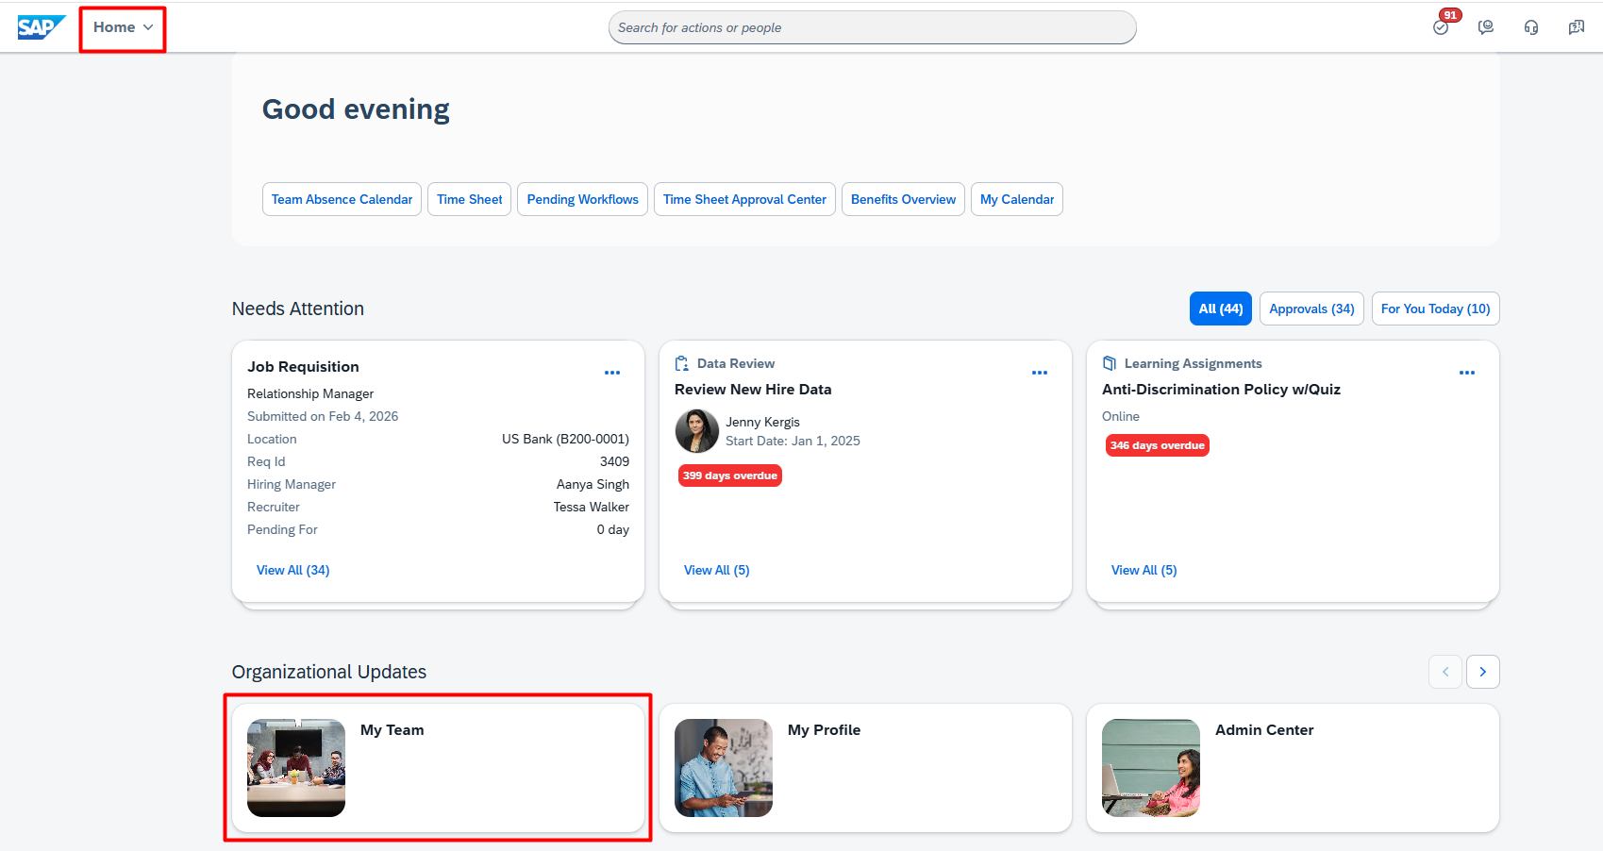

**ENDOFTASK**

**9) Workflow Triggers but it is assigned to the wrong Approver**

Sam Martin’s changes to his First and Last Name should go to HR for Approval but it goes to his Manager instead.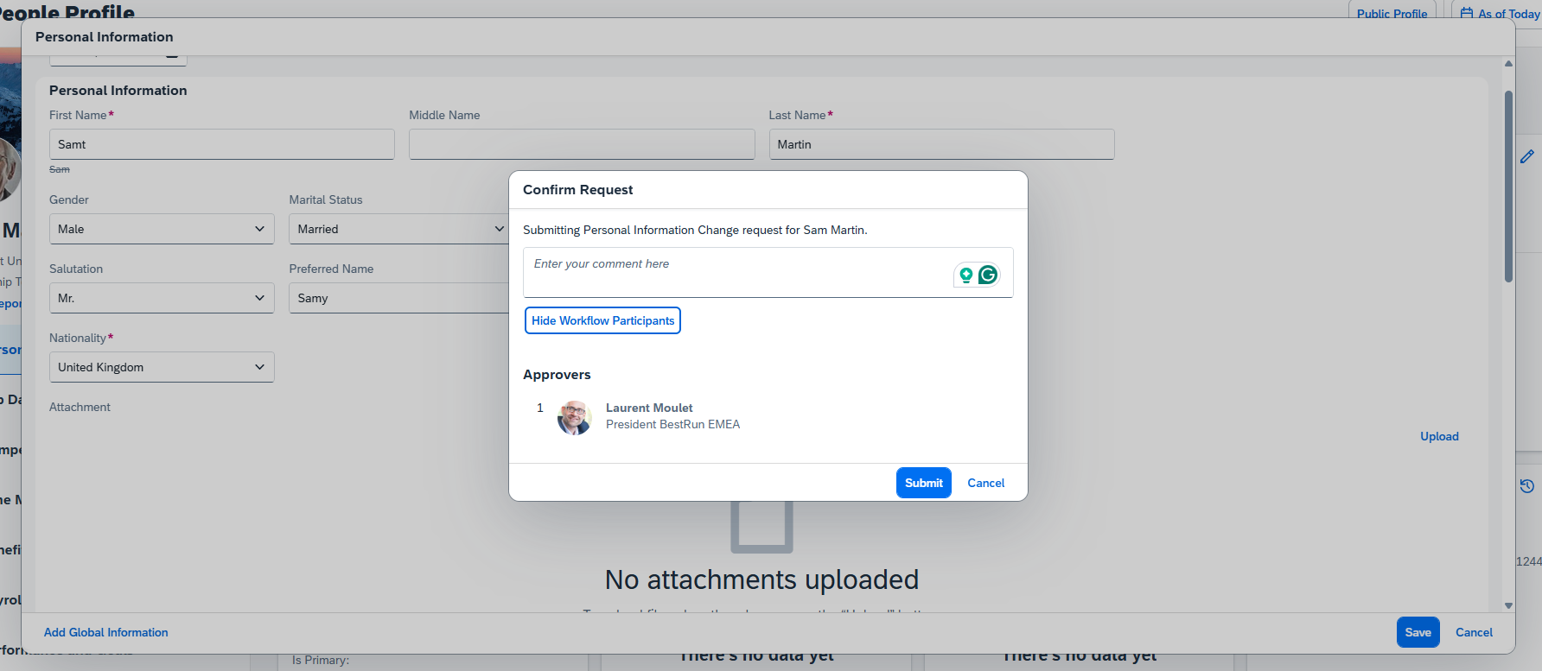

1. Go to “Manage Organization, Pay and Job Structures” 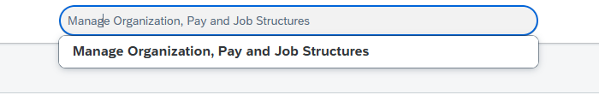
2. Select Workflow in the first dropdown and search “personalinfo” in dropdown next to it. Select “Personal info (personalinfo)”.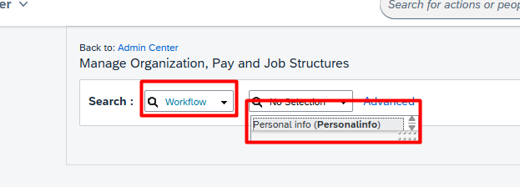
3. Hover over Take Action on the top right and select Make Correction.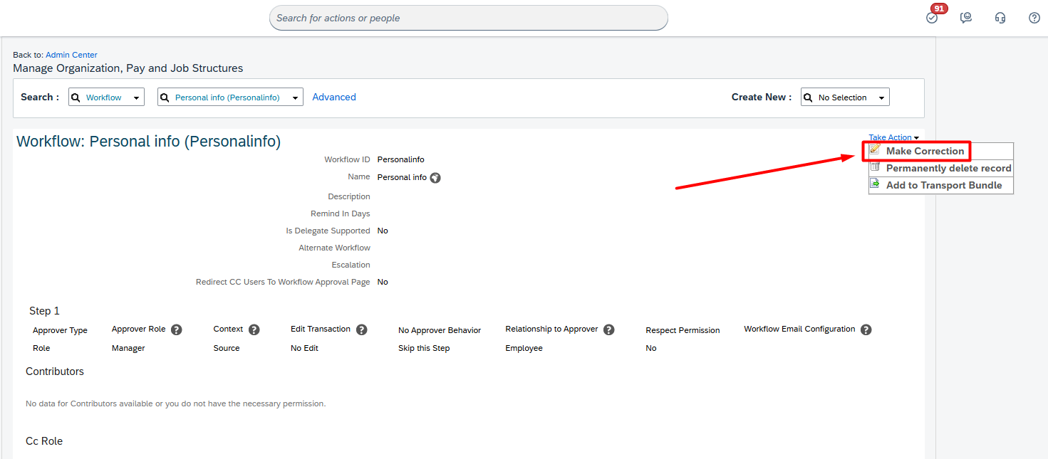
4. The approver is set as the manager which is why he is showing up in the workflow. It should be Employee HR instead.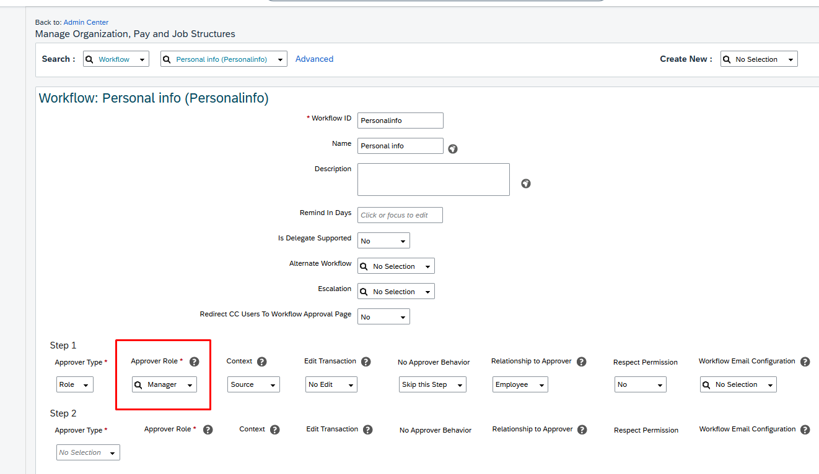
5. Now if we changed that to Employee HR when Sam changes his first or last name, the approver is Martin’s HR Manager.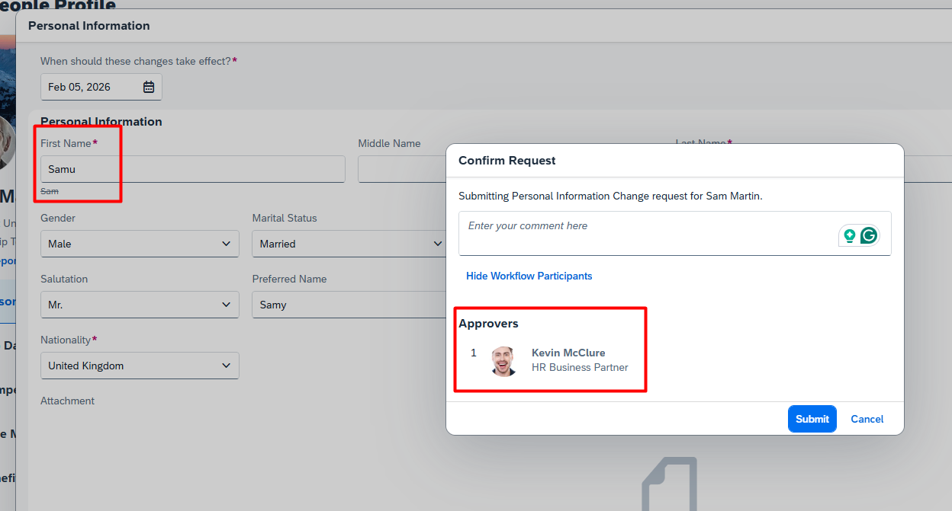

**ENDOFTASK**

**10) Wrong Approver Showing up in workflow**

Sam Martin says that his HR Manager has changed in the company but the approval for the Name changes are still going to his previous HR manager. 

1. Go to Martin’s Profile from top search and Click on the “Job Data” section from the right side. Then click the pencil icon on “Job Relationships”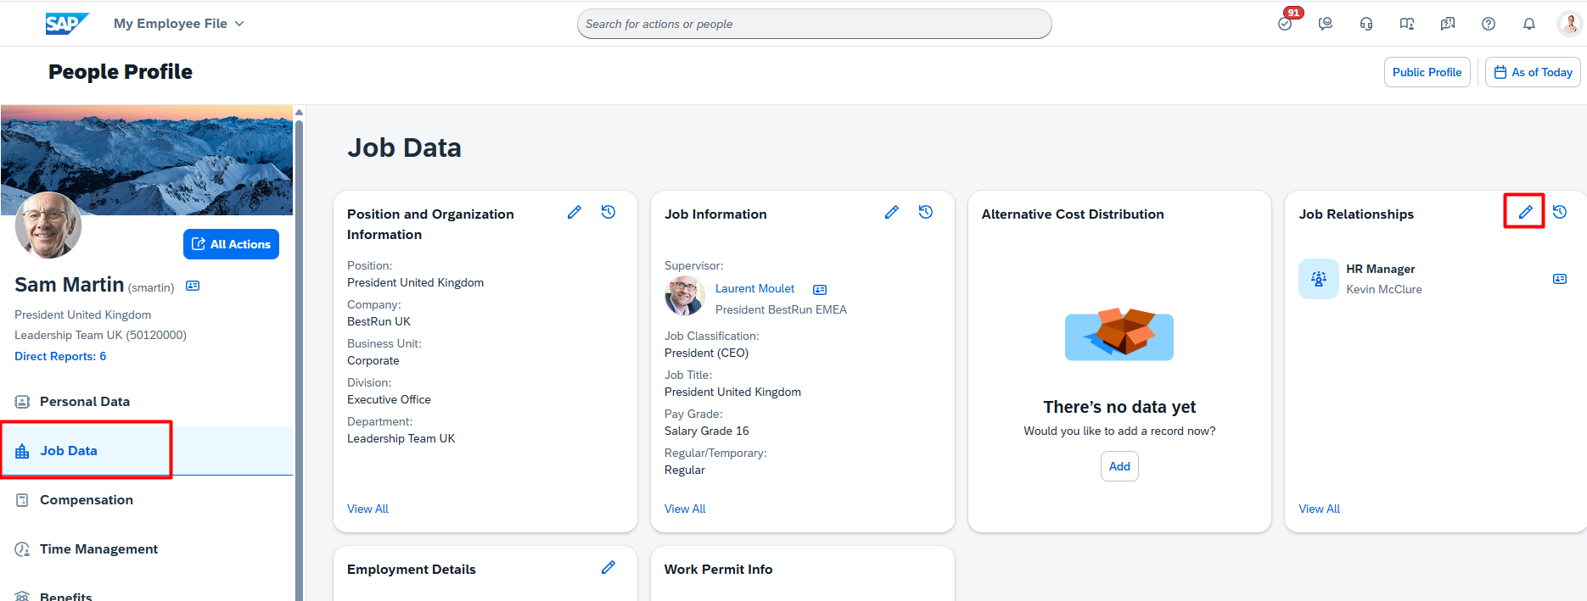
2. Click on the calendar icon on the effective date and select today’s date.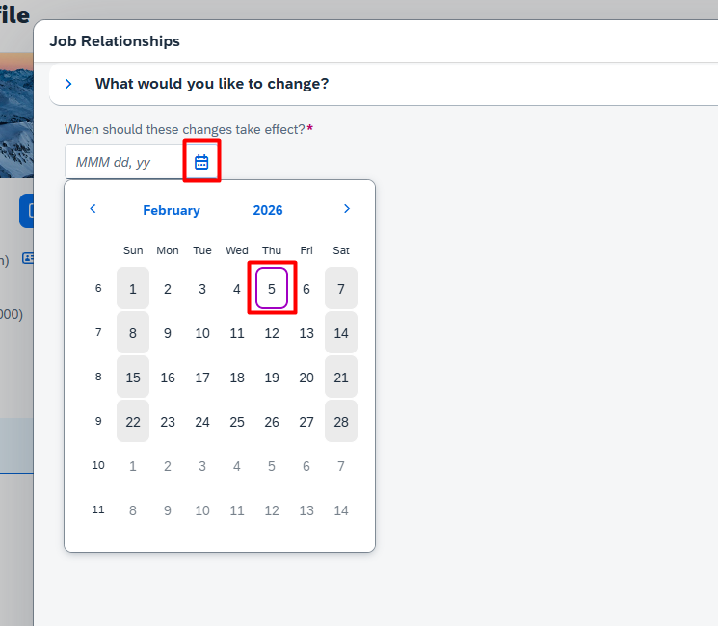
3. Here you can see the Previous HR is named here. This can be changed to the new HR and this issue will be resolved.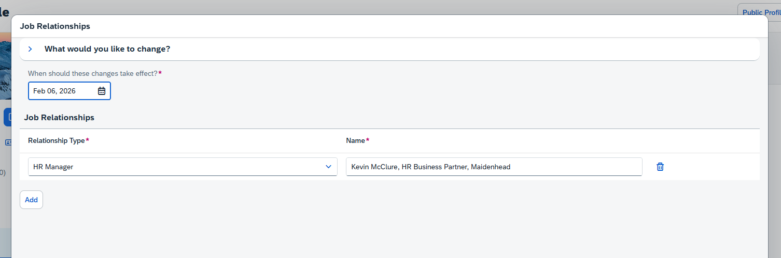
4. Now to verify click on the Personal Data section from the right hand side and then the pencil icon on the Personal Information.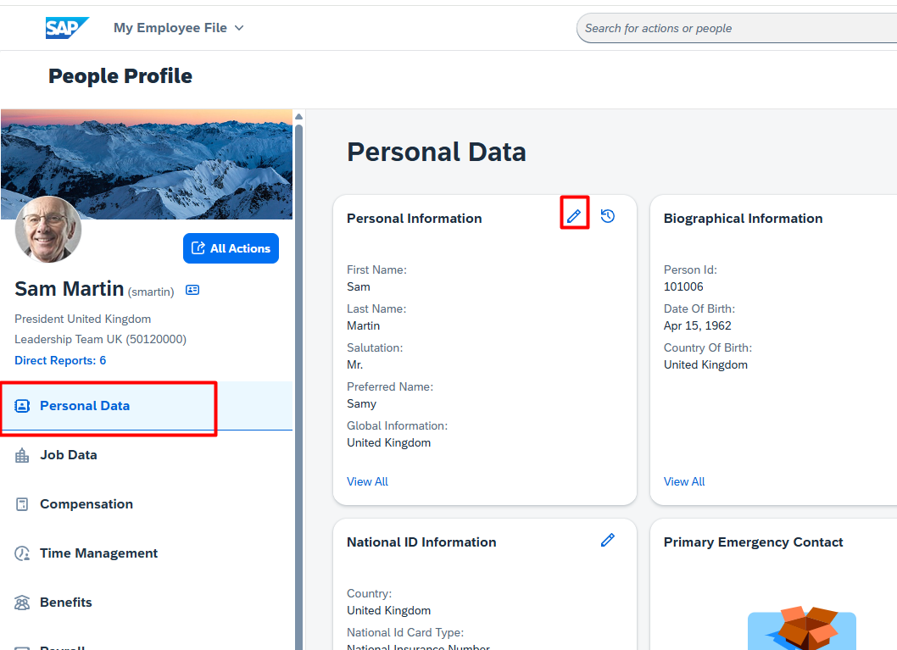
5. Now when you make changes to the First name and Save. The new person you picked is shown in the approvers.